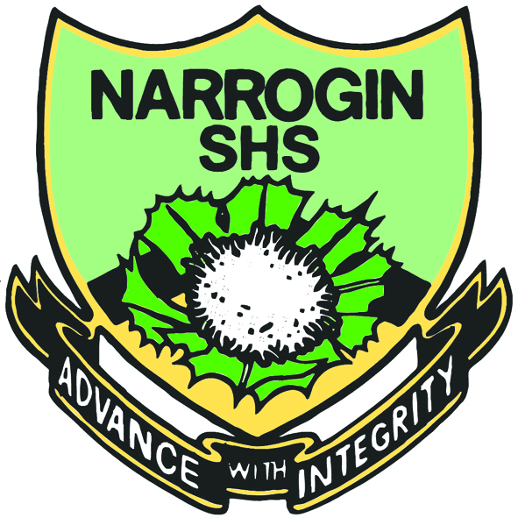
11 ATAR Human Biology

A2HBY Task 16:
Genetics Test

Weighting 8.5%

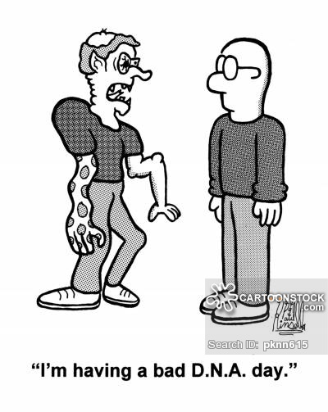

Multiple Choice: 15 marks
Short Answer: 15 marks
TOTAL 30 MARKS

Section A: Multiple Choice (15 Marks)
Answer all questions by placing and X through the most correct answer on the multiple choice answer sheet.

Select the Best Answer

1 The term phenotype refers to the
A type of genes present in an organism.
B external appearance of the organism.
C recessive genes in the organism.
D behaviour of the organism.

- Colour blindness is an example of sex-linked inheritance. A normal woman carrying an allele for colour blindness married a man whom is colour blind. It is most likely that, of their offspring
A all the daughters will be colour blind but none of the sons.
B half will be colour blind, regardless of sex.
C all will be colour blind, regardless of sex.
D half of the daughters, but all of the sons will be colour blind.

- A mutation is best defined as
A the genes responsible for a particular characteristic.
B any observable characteristic which is inherited.
C a change in the genetic material of an organism.
D an organism that carries two different alleles of one gene.

- The diagram below shows chromosomes present in a cell undergoing meiosis. The shaded portions represent maternal DNA and the unshaded portions represent paternal DNA.
Which pair of chromosomes best shows the results of crossing over?

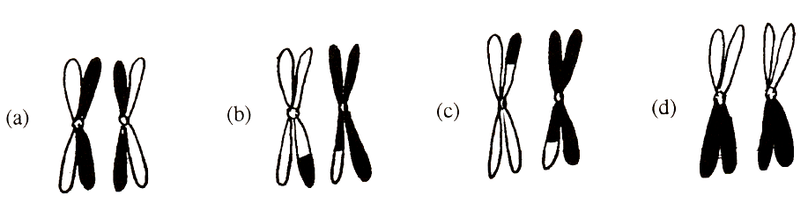

- Which of the following best describes a gene?
A A segment of DNA which codes for a particular protein.
B An inherited characteristic of an organism.
C A chromatid of a chromosome.
D An enzyme responsible for a particular characteristic.

- In humans tongue-rolling (T) is dominant to unable to tongue roll (t). Which one of the following crosses would result in half of the offspring being able to tongue roll?
A TT X tt
B Tt X tt
C Tt X Tt
D TT X Tt

- A species is known to reproduce asexually. Which of the following is most likely to be a correct statement?
A A large number of offspring are produced with a high level of genetic variation between them.
B Very few offspring are produced, with little genetic variability.
C Large numbers of offspring are produced with very little genetic variability.
D Few offspring are produced, but no two are genetically alike.

- In Holstein Friesian cattle Black coat colour is dominant to red coat colour and is considered a desirable feature of the breed. The alleles for coat colour are autosomal. For a particular bull to have breeding value it must be homozygous for black coat colour. Which of the following procedures would be the best way to determine whether a bull is homozygous for black coat?

A Mate the bull with 10 red cows and check the colour of the offspring.
B Mate the bull with 10 black cows known to be heterozygous for coat colour and check the colour of the offspring.
C Mate the bulls with 10 cows of random coat colour and check the colour of the offspring.
D Mate the bull’s mother and father again and check the colour of their offspring.

- Examine the following diagram

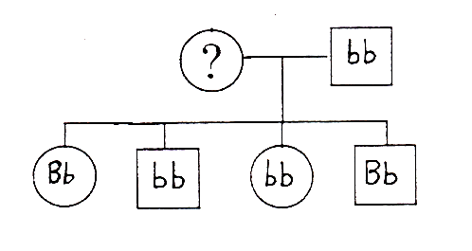

The gene combination in the mother must be

A BB
B Bb
C bb
D Bb or bb.

10 A geneticist was studying coat colour in a herd of Shorthorn cattle. She performed the following cross:
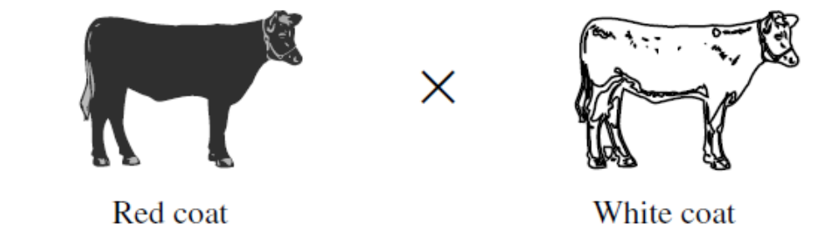

The results of the cross are shown in the table below.

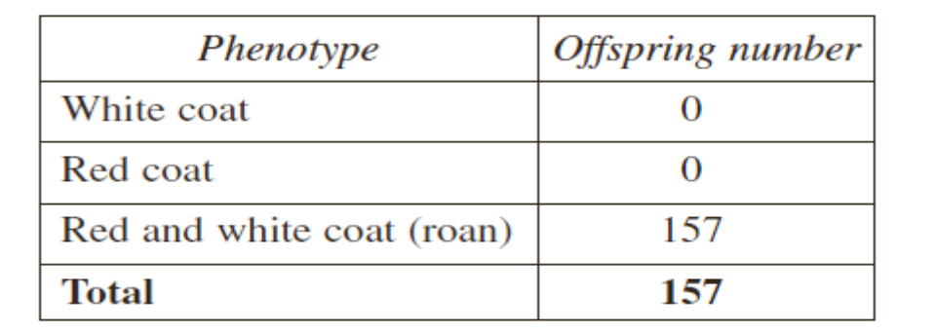

The roan coat colour was the result of which type of inheritance?
- Co-dominance
- Dominant/recessive
- Heterozygous parents
- Hybridisation

- Processes which can lead to variation among offspring in sexually reproducing organisms are
A Random alignment and crossing over during meiosis
B Genetic Drift
C Mitosis
D Adaptation

- An allele for a recessive disorder in mice could most likely be eliminated from a population in a single generation by

A removing individuals who are homozygous for the disorder from the population.

B ensuring there is interbreeding with individuals from other populations.
C increasing the size of the population.
D allowing only homozygous dominant individuals to breed.

- Which of the following statements about gametogenesis is NOT true?

A Each primary spermatocyte is formed by mitosis.
B Four sperm are formed from each primary spermatocyte.
C One ovum is formed from each primary oocyte.
D After the birth of a male child, no new primary spermatocytes form in his testes.

14 A reproductive cell of on organism contains:

A half as many chromosomes as other body cells and genes concerned with half the physical characteristics of the organism’s offspring.
B the same number of chromosomes as other body cells and genes concerned with all the physical characteristics of the organism’s offspring.
C half as many chromosomes as other body cells and genes concerned with all the physical characteristics of the organism’s offspring.
D the same number of chromosomes as other body cells and genes concerned with half the physical characteristics of the organism’s offspring.

- Meiosis results in
A 2 haploid daughter cells
B 4 haploid daughter cells
C 2 diploid daughter cells
D 4 diploid daughter cells

Part B Short Answer Section 15 marks
1
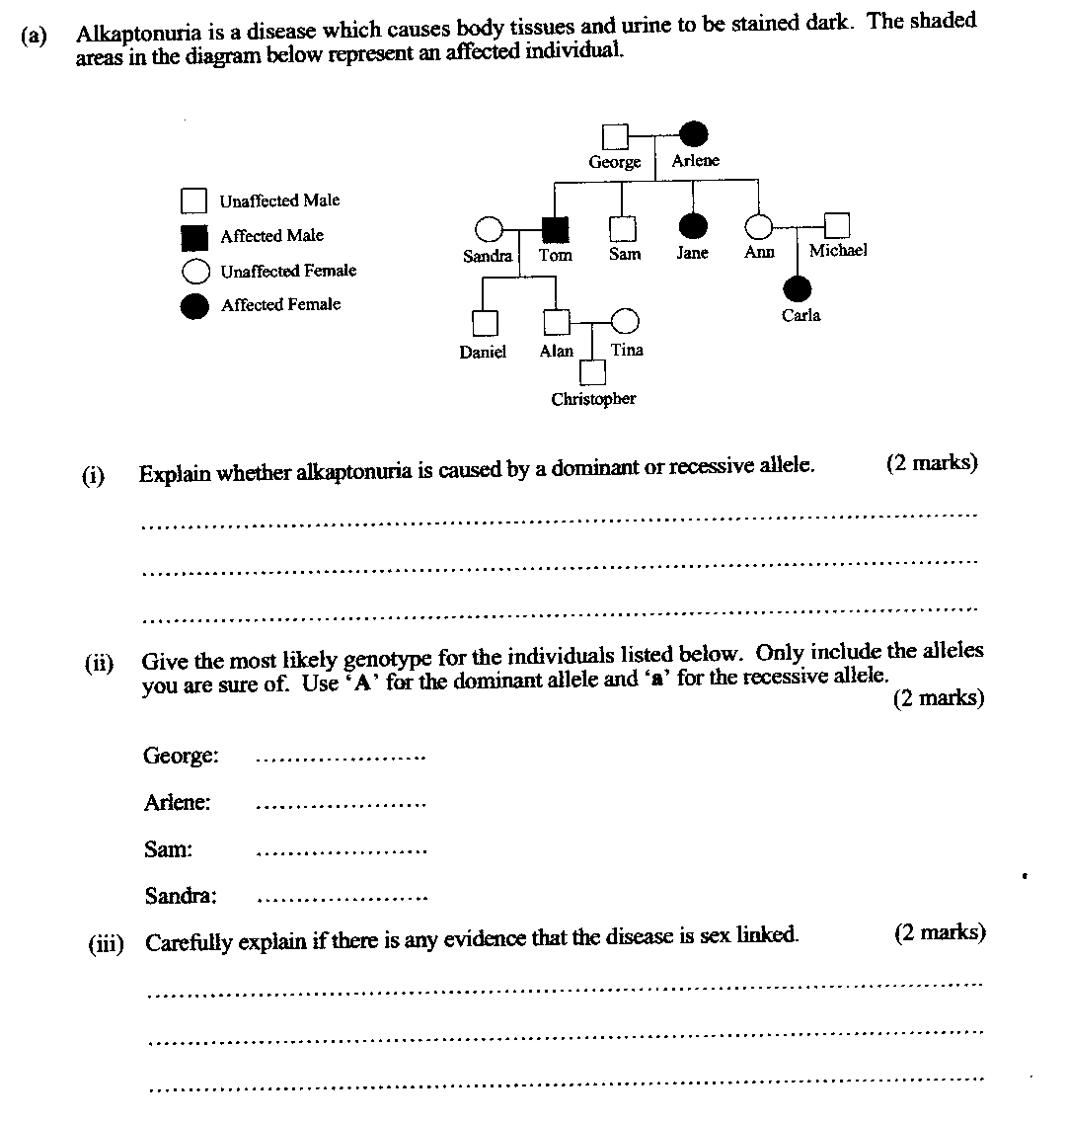

2 The pedigree drawn below represents the inheritance of a rare genetic condition that affects normal liver functions. Individuals who inherit this condition experience no symptoms until they become middle-aged (40-55 years). At this point in their life, affected individuals will present with severe digestive and blood composition problems.

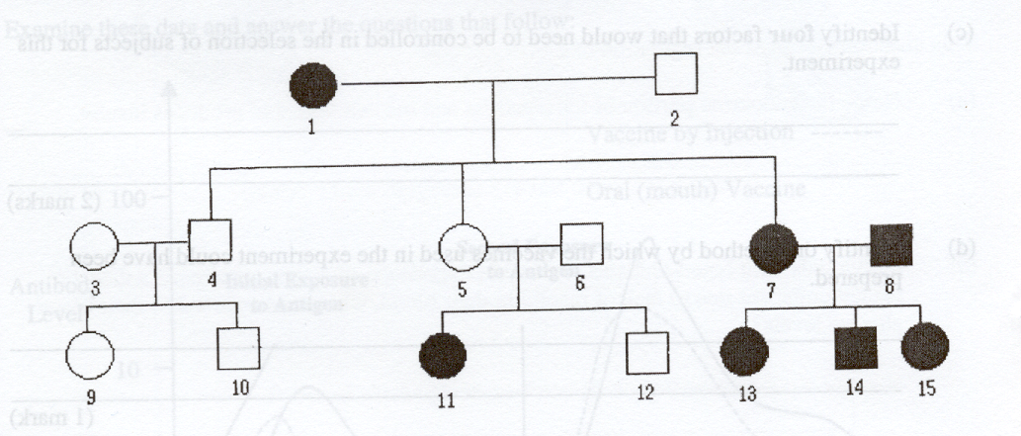

a What is the mode of inheritance for this condition?

__________________________________________________________________

__________________________________________________________________

(2 mark)
b Outline the evidence in the pedigree that provides definite support for your answer in part a above.

__________________________________________________________________

__________________________________________________________________

__________________________________________________________________

__________________________________________________________________
(2 marks)

3 Nick’s wife Maria has a history of red-green colour blindness in her family. Jack, their two-year old son, may be red-green colour blind. Maria’s brothers, Vincent and Paul, are colour blind but her brother, James, is not. Maria’s mother Anne, is a carrier of red-green colour blindness. Her father, John, is unaffected.

(a) Construct a family pedigree to show the inheritance of this sex-linked genetic
disorder. (2 marks)

(b) Predict whether Jack will be colour blind. Justify your answer. (3 marks)

__________________________________________________________________

__________________________________________________________________

__________________________________________________________________

__________________________________________________________________

__________________________________________________________________

__________________________________________________________________

__________________________________________________________________

__________________________________________________________________

11 ATAR Human Biology

Task 16:
Genetics Test

NAME:_____________________________

DATE:______________________________

Section A: Multiple choice (15 Marks)
Answer all questions by placing and X through the most correct answer on the multiple choice answer sheet.

1. a b c d 13. a b c d
2. a b c d 14. a b c d
3. a b c d 15. a b c d
4. a b c d
5. a b c d
6. a b c d
7. a b c d
8. a b c d
9. a b c d
10. a b c d
11. a b c d
12. a b c d

